**Challenge #1**

**A 3-tier environment is a common setup. Use a tool of your choosing/familiarity create these**

**Resources. Please remember we will not be judged on the outcome but more focusing on the**

**Approach, style and reproducibility.**

Answer:

For the above task we using Google Cloud Platform (GCP). So we are using GCP services like Virtual Private Cloud Networks (VPC), Google Compute Instances (VMs), Load Balancing Services, and also we are using autoscalaing.

For this first we are creating a VPC network with name “vikas-vpc” and also creating subnets so that we can use the vpc and the subnet to create an Instance template which is later used to create an instance group. And after that finally we create a HTTP Load Balancer to create a Frontend and Backend to our Application.

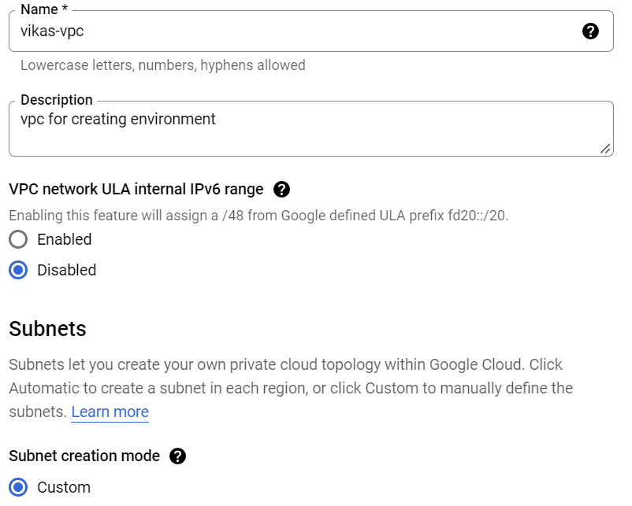

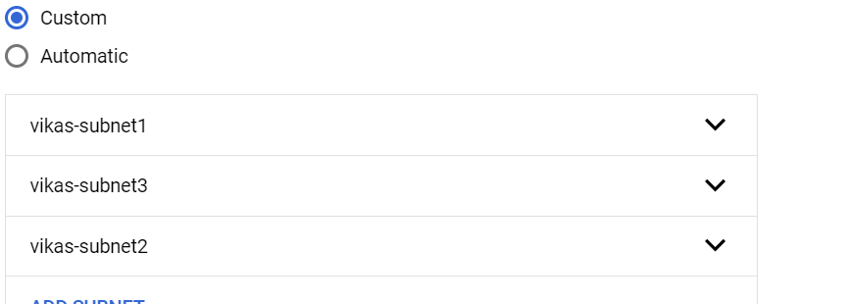

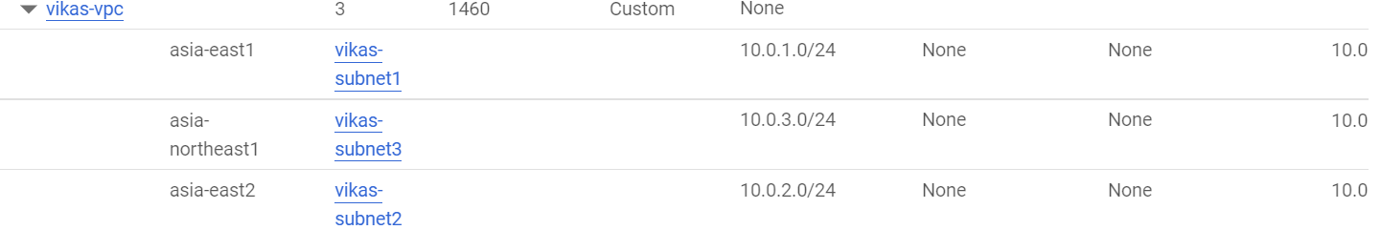

Now we are creating an instance template so we can use it while creating instance group which supports auto scaling. We are using nginx automation script in instance template, so when we launch an instance group configured with Load Balancer users can access to web server.

And also we are using image centos and also using subnets and vpc we have configured.

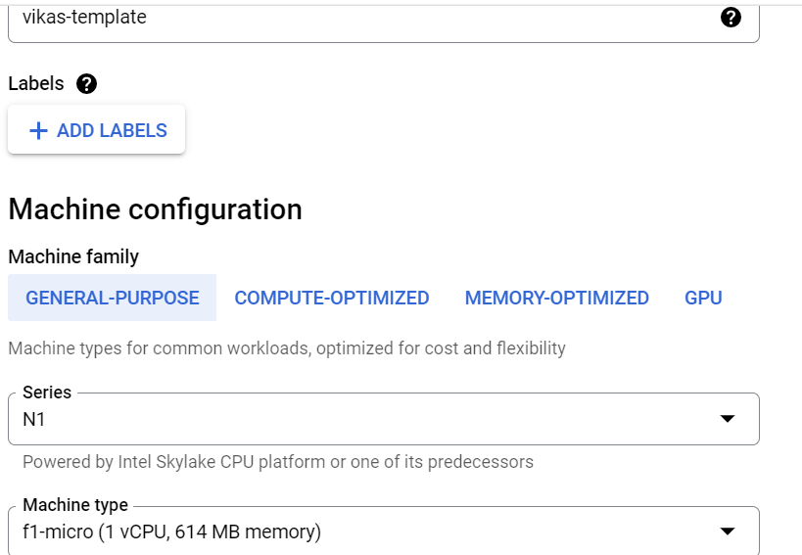

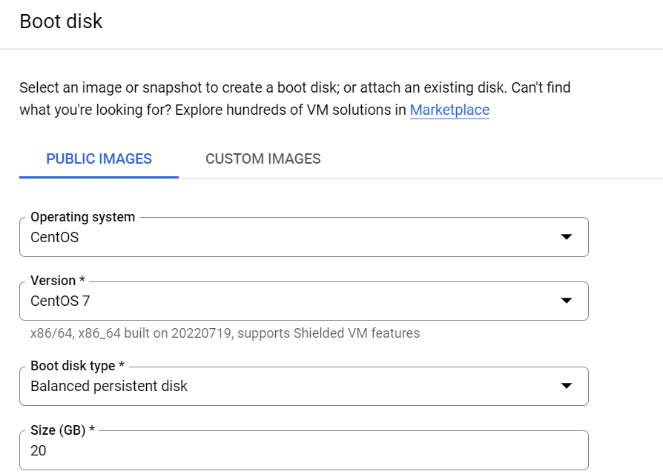

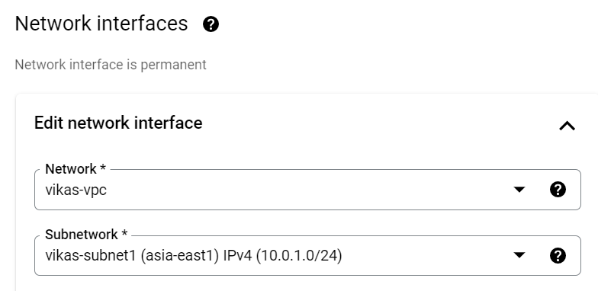

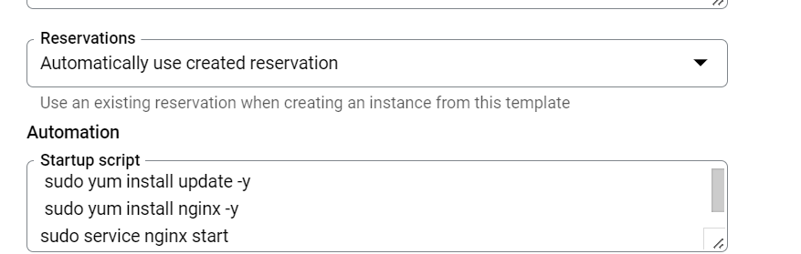

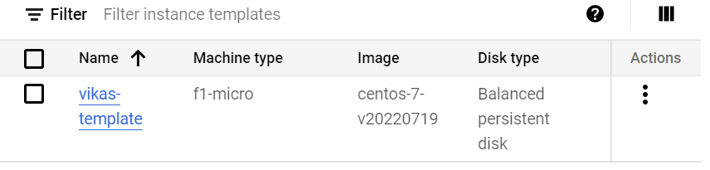

After creating instance template, now go to instance group and create it using template we have created.

We have to create an Instance Group, we are using a single zone and also we have to auto scaling metrics depends on our requirement like setting up the percentage of CPU Utilization and then we create our Instance Group.

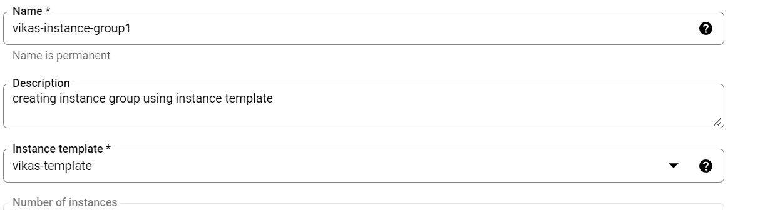

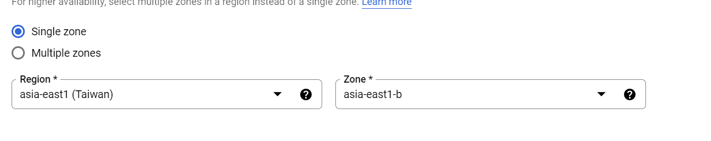

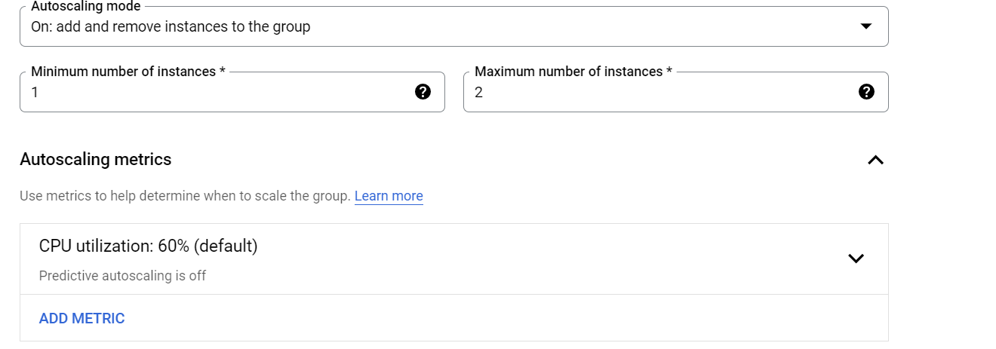

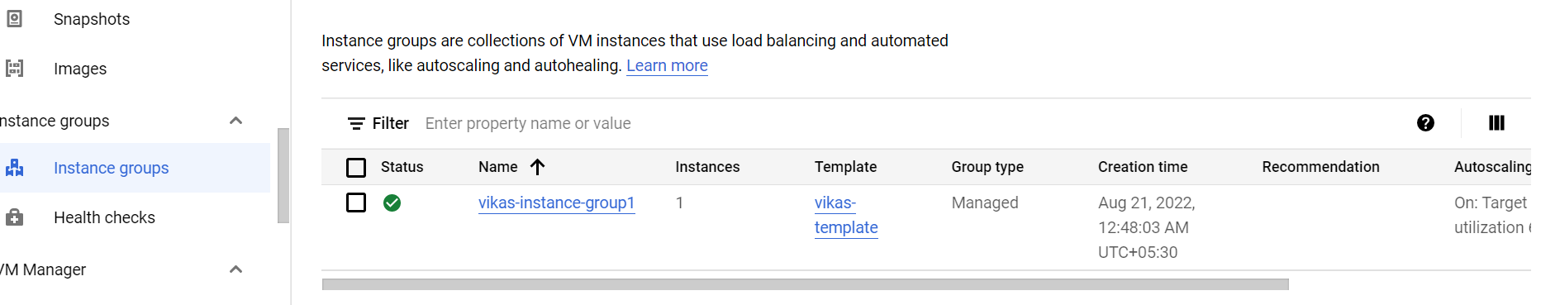

Now we have to create the Load Balancer, for that we are using HTTP Load Balancer. Here we are choosing our internet facing as “From internet to our vms” and also we are choosing a global http load balancer. And we have to configure both Frontend and Backend services for our application, and also by adding Health checks to our load balancer.

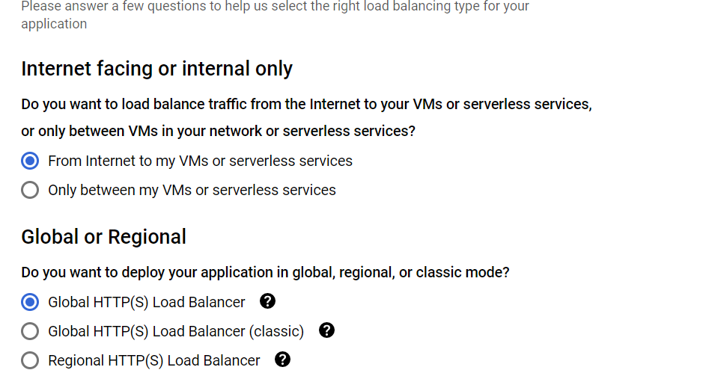

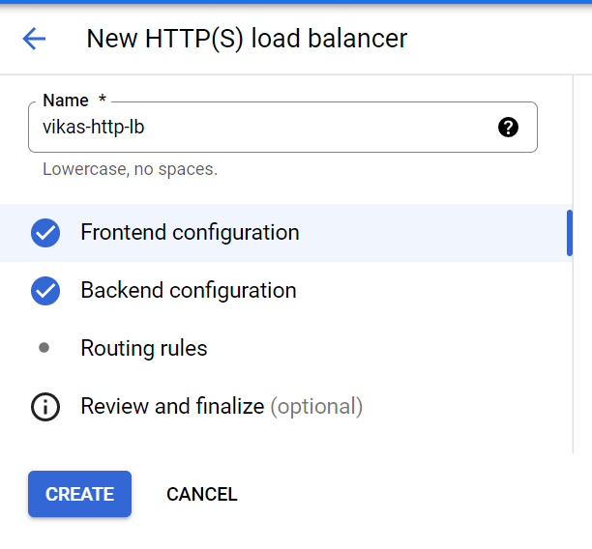

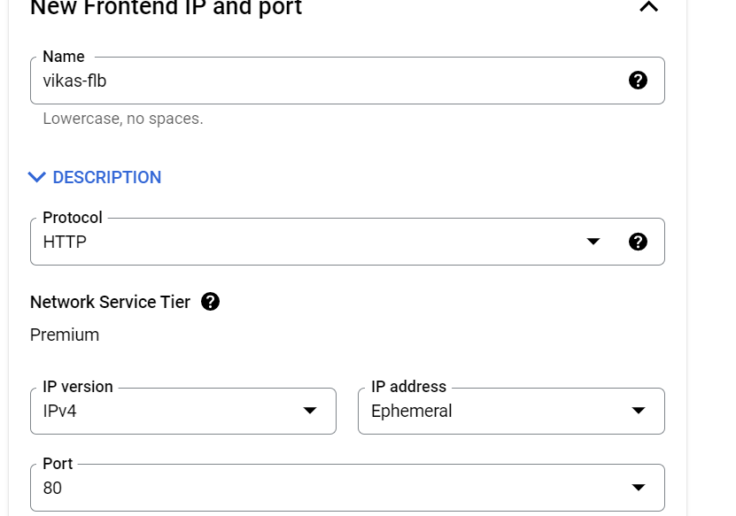

For backend choose create a backend service

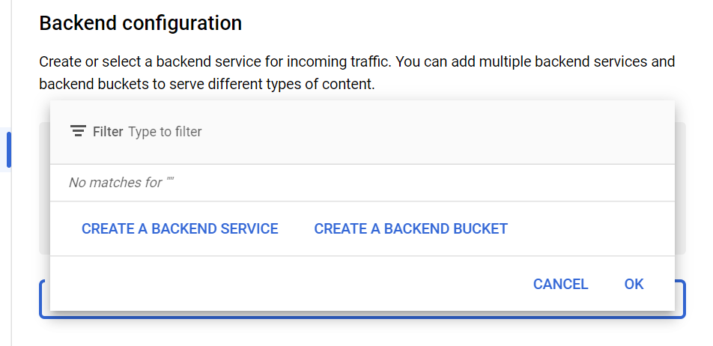

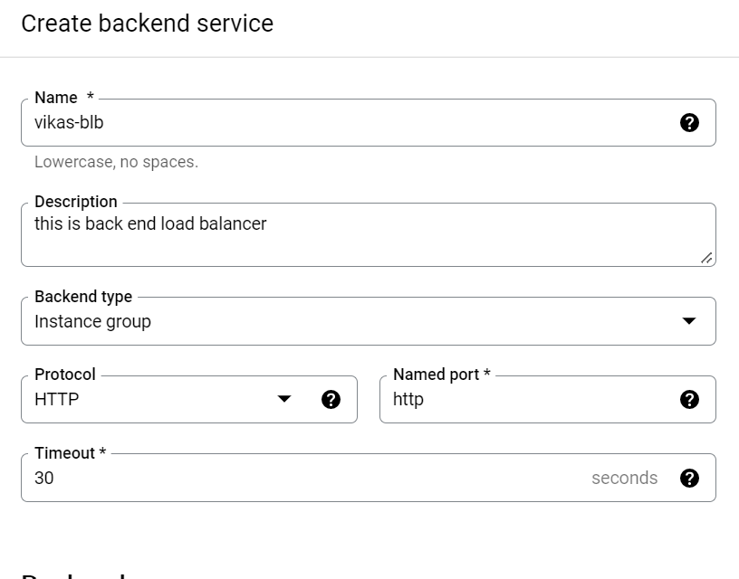

Now we have to specify the port for our backend services.

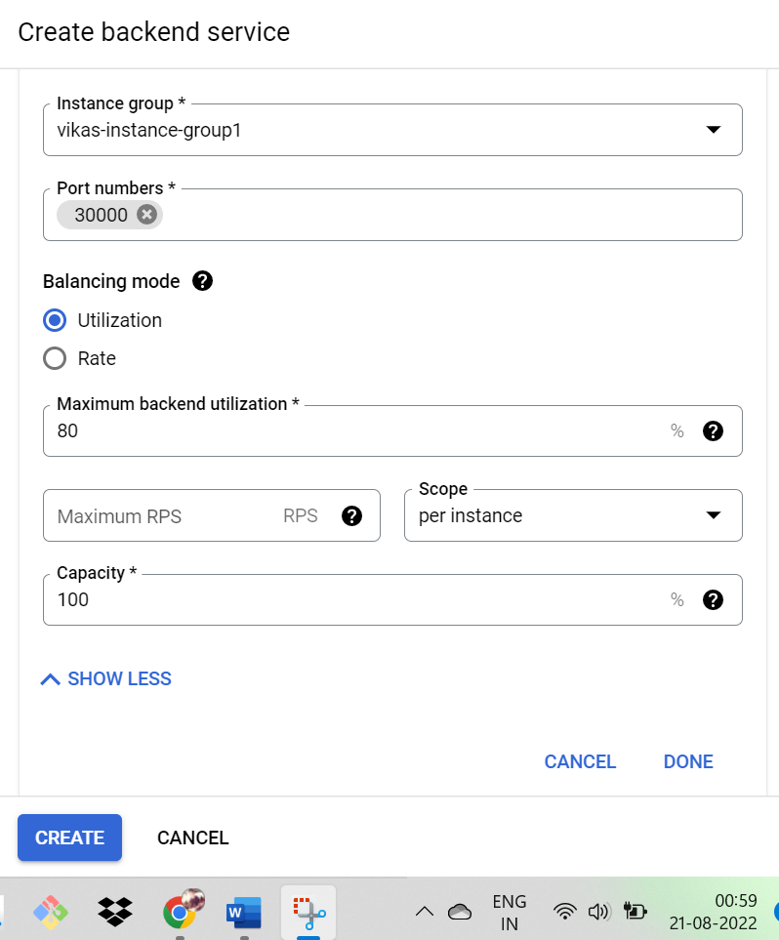

Now we have to create a health check for the the load balancer for backend.

